02/28/2026, Menlo Church Worship, Legacy (last week)

https://www.youtube.com/live/EYP2zTQK3QE?si=L1iGmo0BEvQpljhN

“I Am With You in the Desert | I Am: The God Who Gets Close,” Phil EuBank, Lead Pastor



Introduction:

12:00/1:15:02

 

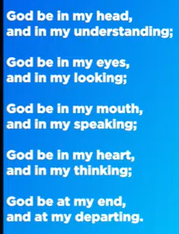

19:00/1:15:02

 

Phil EuBank, Lead Pastor

We are in the new series of “I Am: Arrival” Series.

Today, we start the journey toward Easter (April 5, 2026). We will study the Exodus chapter 3.

In Bay area, we all have constant rival arrival at all time.

We have the dream house that commute to work. It is the 21st century version of promised land.

If work is not smooth and frustrated, it is not closed to the promised land.

We spend the whole life to do that. At the end, we see God Is waiting for us at the finish line.

25:30/1:15:02

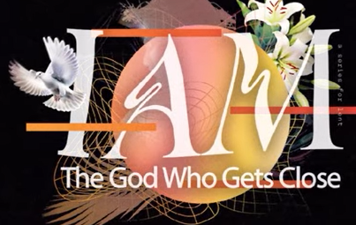

The God Who Gets Close

The concept of "The God Who Gets Close" highlights a deity that is intimately involved in human life, breaking barriers to foster a personal relationship rather than remaining distant. Central themes include the promise that drawing near to God initiates reciprocal closeness, God's pursuit of humanity through vulnerable love, and His presence with the brokenhearted.

* **Biblical Promise:** James 4:8 encourages believers to "Draw near to God and He will draw near to you".
* **Vulnerable Love:** The incarnation (Jesus as a baby) is seen as God removing barriers to achieve intimate, tender, and accessible connection.
* **Active Presence:** God is described as being closer to individuals than their own "jugular vein" and actively involved in the details of life.
* **Accessibility:** Intimacy with God is not based on status or religious acts, but on a willing heart, often found in times of brokenness.
* **Overcoming Distance:** When feelings of separation arise, it is an invitation to step forward, often through confession or simply seeking Him, allowing Him to move closer.

This perspective emphasizes a God who is not just a distant creator, but a personal, loving presence that is intimately acquainted with human experiences.

God is a distant creator with personal/loving presence.

26:00/1:15:02

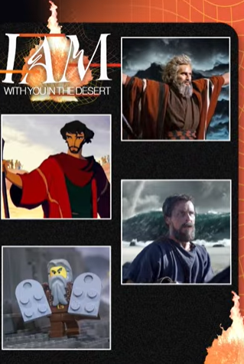

God With you in the desert

The "desert" is a powerful biblical metaphor for seasons of testing, isolation, and spiritual dryness where God’s presence becomes a lifeline rather than a luxury. Even in the most barren places, you are not alone; God uses these seasons to refine your faith and reveal His sufficiency.

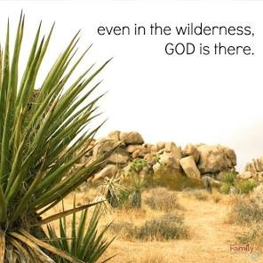 

**How God Meets You in the Desert**

* **A Place of Divine Encounter**: In Hebrew, the word for desert (**midbar**) shares a root with the word for speaking (**medaber**). It is often in the silence of the wilderness that God’s voice becomes clearest.
* **Provision in Scarcity**: Just as He provided manna and water from a rock for the Israelites, He promises to "make a way in the wilderness and rivers in the desert" for you (Isaiah 43:19).
* **Refinement and Growth**: Desert seasons are often a prerequisite for a "new level" of purpose. Jesus was led into the desert by the Spirit before starting His ministry to demonstrate that "man does not live by bread alone".
* **Intimacy Over Comfort**: Being "stripped" of self-sufficiency in the desert forces an intimacy with God that is hard to find in times of plenty.

**Strategies for the Desert Season**

1. **Seek Him Earnestly**: Follow the example of **David** in Psalm 63, who sought God "in a dry and weary land where there is no water".
2. **Depend on the Word**: Use Scripture as a "lamp" when your path feels obscured by the shifting sands of your circumstances.
3. **Worship Through It**: Don't wait for the miracle to praise Him; worship is a weapon that shifts your focus from the barrenness to the Provider.

If you'd like, I can share **specific Bible verses** for encouragement or help you explore the **stories of biblical figures** who found their breakthrough in the wilderness.

The desert is the most barren place. God uses desert to refine your faith.

29:00/1:15:02

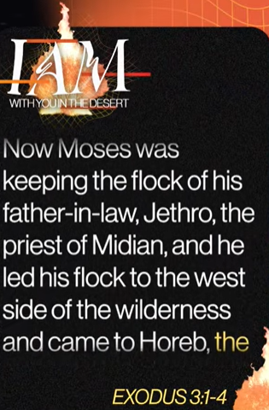 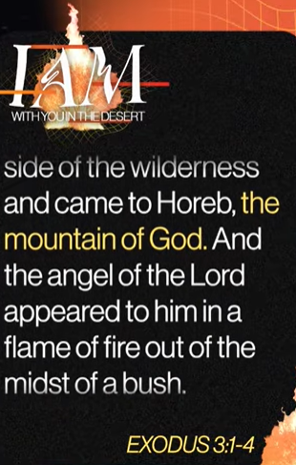 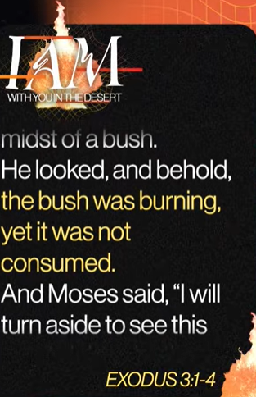

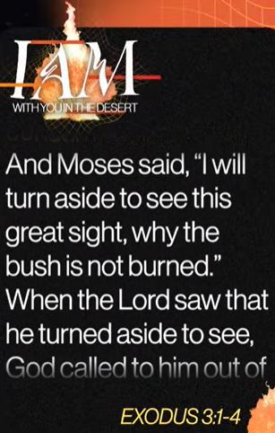 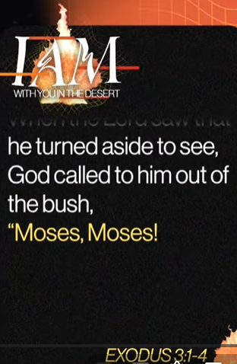

Exodus 3:1-4

English Standard Version

**The Burning Bush**

**3**Now Moses was keeping the flock of his father-in-law, Jethro, the priest of Midian, and he led his flock to the west side of the wilderness and came to Horeb, the mountain of God. **2**And the angel of the Lord appeared to him in a flame of fire out of the midst of a bush. He looked, and behold, the bush was burning, yet it was not consumed. **3**And Moses said, “I will turn aside to see this great sight, why the bush is not burned.” **4**When the Lord saw that he turned aside to see, God called to him out of the bush, “Moses, Moses!” And he said, “Here I am.”

The main point of

**Exodus 3:1-4**

 is **God’s personal and supernatural initiative** to get Moses’ attention and call him from a life of obscurity to a divine mission.

The passage highlights several key themes:

* **The Miraculous Manifestation**: God uses the "great sight" of a **burning bush** that is not consumed to interrupt Moses' mundane routine as a shepherd.
* **Divine Presence and Holiness**: The appearance of the **Angel of the LORD** in the fire establishes the location as "**holy ground**," demanding reverence and the removal of Moses' sandals.
* **God’s Personal Call**: When Moses "turns aside" to investigate, God calls him **by name**—"Moses, Moses!"—signaling an intimate and urgent invitation into a specific vocation.
* **Preparation for Deliverance**: This encounter serves as the pivotal start of the **commissioning of Moses** to lead the Israelites out of slavery in Egypt.

If you'd like, I can:

* Explain the **theological meaning of the "I AM" name** revealed later in the chapter.
* Detail the **five excuses** Moses gave God and how God answered them.
* Compare this call story to **other biblical callings** (like Isaiah or Paul).

32:00/1:15:02



How many burning Bush Moments have you missed this week on your way to your own “promised Land”?

In the fast-paced rush toward our personal goals—the "promised lands" of career success, family stability, or financial security—it is easy to miss the **divine interruptions** meant to guide us.

A "burning bush moment" is rarely a planned appointment; it is often a **"great sight" in the middle of a mundane routine** that requires us to "turn aside" to investigate.

**Common "Bushes" We Miss**

We often overlook these moments because they don't look like miracles; they look like **distractions or routine events**:

* **The Mundane Routine**: Like Moses tending sheep, we may be so focused on the "next task" (laundry, emails, commuting) that we fail to see God in the ordinary.
* **The Voice of Others**: Insights from a spouse, child, or friend can often be the "burning bush" where God is trying to get our attention.
* **Painful Interruptions**: Unexpected challenges, like a job loss or a difficult relationship, can be divine appointments designed to awaken us to a new calling.
* **Internal Restlessness**: A persistent "tug on the heart" or a recurring thought that keeps you up at night may be the fire that is meant to illuminate your true path.

33:00/1:15:02

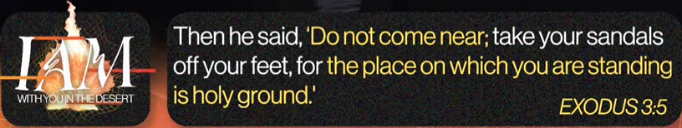

Exodus 3:5

English Standard Version

**5**Then he said, “Do not come near; take your sandals off your feet, for the place on which you are standing is holy ground.”

The main point of

**Exodus 3:5** is the **absolute holiness of God** and the requirement for **reverence** and **humility** in His presence.

**Core Themes**

* **The Sanctity of Presence**: The ground was not holy due to its location, but because God was manifesting there. This highlights that holiness is **relational** rather than geographic.
* **Reverence and Humility**: The command to "take off your sandals" was a cultural sign of respect, submission, and recognition of one's own unworthiness before the Divine.
* **Separation from the Profane**: Removing sandals symbolized shedding the "dust" or "defilement" of the world before approaching the Holy One.
* **Preparation for Mission**: This encounter served as a prerequisite for Moses' commissioning; he had to first recognize God's holiness before he could serve as His messenger.

**Biblical Context**

* **Verse Text**: "Do not come any closer... Take off your sandals, for the place where you are standing is holy ground" (NIV).
* **Parallel**: A near-identical command is given to **Joshua** in Joshua 5:15 when he encounters the commander of the Lord's army.

34:00/1:15:02



The Desert Dismantles what deforms us

In the context of Moses’ encounter in **Exodus 3:5**, the idea that **"the desert dismantles what deforms us"** refers to the spiritual stripping away of the "false self" or worldly identity to reveal our true nature before God.

**How the Desert Dismantles and Reshapes**

* **The "Great Undoing"**: The desert is viewed as a place of "great undoing" where truth-telling disrupts our comfort and forces us to let go of preconceived notions and ego-driven identities.
* **Removing the "Sandals" of the Past**: Taking off sandals symbolizes shedding the "dust" of Egypt—the habits, guilt, and worldly attachments (like Moses’ past as an Egyptian prince) that "deform" our spiritual potential.
* **Distillation to Rawness**: The harshness of the desert environment distills a person into their "absolute rawness," revealing naked vulnerability and a total dependence on Divine provision rather than human strength.
* **A Place of Pruning**: Known as the "backside of the desert," this space is a strategic environment where God prunes or "dismantles" the parts of us that are not fit for His mission, preparing us for a "greater work."

**The Result of the Dismantling**

By dismantling the "deformed" self—whether that be pride, self-reliance, or old traumas—the desert experience **reconstitutes** the individual into their true self, "hidden with Christ in God." For Moses, 40 years in the desert were required to "get Egypt out of him" so he could be reformed into a leader capable of hearing God's voice clearly.

36:00/1:15:02



It Reveals God’s Heart

In the context of the desert dismantling us, the phrase **"It reveals God's heart"** refers to the moment when, once we are stripped of our self-reliance and "deformities," we are finally able to see God’s true nature and intentions.

**How the Desert Reveals God’s Heart**

* **From Judge to Deliverer**: In the quiet of the desert, God reveals that He is not just a distant, holy judge but a **compassionate Deliverer**. In **Exodus 3:7-8**, immediately following the "holy ground" command, God reveals His heart by saying, "I have surely seen the affliction of My people... and I have come down to deliver them".
* **The Vulnerability of God**: The burning bush—a humble, common plant that is on fire but not consumed—is often seen as a revelation of God’s heart: He is a **sustaining fire** who desires to dwell within His people (even in their "lowly" or "thorny" state) without destroying them.
* **Personal Invitation**: By calling Moses by name ("Moses, Moses!"), God reveals a **relational heart**. The desert removes the "noise" of Egypt so that the individual can hear the specific, intimate call of a God who knows them personally.
* **Provision in Lack**: The desert environment reveals God’s heart as a **Provider**. When human resources are gone, God reveals Himself through manna and "water from the rock," proving that His heart is committed to sustaining His children even in the most barren places.

**The Theological Outcome**

The "dismantling" is never the end goal; it is the **clearing of the lens**. Once the "sandals" (past identities, sins, and self-protections) are removed, the "deformed" heart is replaced with a **"soft, pliable heart"** that can finally mirror the heart of God.

If you'd like to dive deeper, I can:

* Explore the meaning of the name **"I AM WHO I AM"** as a revelation of God's character.
* Discuss the concept of **"Thin Places"** where the desert and the divine intersect.
* Explain how this desert theology appears in the life of **Jesus** during His 40 days of temptation.

36:19/1:15:02

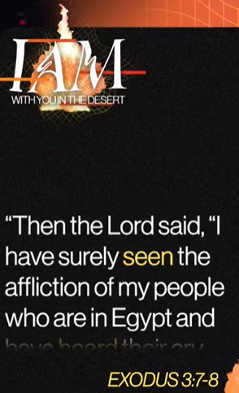 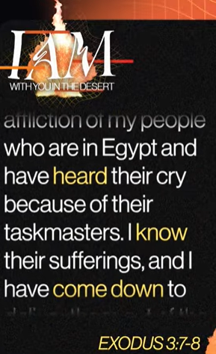 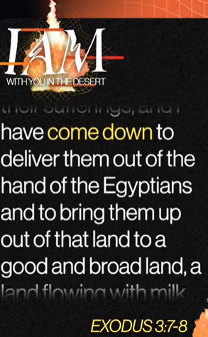

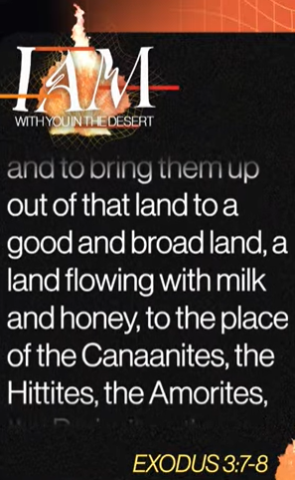 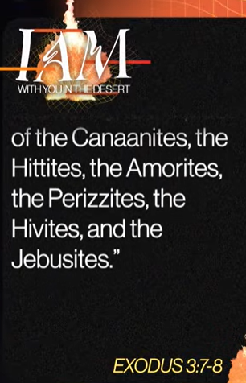

Exodus 3:7-8

English Standard Version

**7**Then the Lord said, “I have surely seen the affliction of my people who are in Egypt and have heard their cry because of their taskmasters. I know their sufferings, **8**and I have come down to deliver them out of the hand of the Egyptians and to bring them up out of that land to a good and broad land, a land flowing with milk and honey, to the place of the Canaanites, the Hittites, the Amorites, the Perizzites, the Hivites, and the Jebusites.

The main point of **Exodus 3:7-8** is God's **active compassion** and His **commitment to deliver** His people from suffering. This passage marks the moment God reveals to Moses His intent to rescue the Israelites from slavery in Egypt and lead them to the **Promised Land**.

**Key Themes of the Passage**

* **God’s Attentiveness**: The text emphasizes four distinct actions that demonstrate God's personal involvement:
  + **He Sees**: "I have surely seen the affliction of my people".
  + **He Hears**: "I have heard their cry because of their taskmasters".
  + **He Knows**: "I know their sorrows".
  + **He Acts**: "I am come down to deliver them".
* **A Shift in Relationship**: For the first time, God refers to Israel as "**My people**," signaling a formalizing of His covenant relationship with them.
* **The Goal of Deliverance**: God’s purpose is twofold: to **rescue** them from oppression and to **bring them up** into a "good and spacious land, a land flowing with milk and honey". This describes a place of abundance, fertility, and rest.
* **Human Agency**: While God declares *He* has come down to deliver them, He immediately follows this in the subsequent verses by commissioning **Moses** as His human instrument for the task.

**Spiritual & Theological Significance**

* **Faithfulness to Promises**: The passage shows God fulfilling a prophecy made centuries earlier to Abraham (Genesis 15:13-14) about the eventual liberation of his descendants.
* **Foreshadowing of Christ**: Many commentators view this as a "type" or shadow of the **New Testament exodus**, where God "comes down" in the person of Jesus to deliver humanity from the bondage of sin.

If you're interested, I can provide a **verse-by-verse breakdown** of these themes or explain how this scene fits into the **larger story of the Exodus**.

40:00/1:15:02



But I will be with You…

In **Exodus 3:12**, God's response "**But I will be with you**" is the definitive answer to Moses' insecurity. When Moses asks, "Who am I?" (v. 11), God essentially tells him that his identity and past are irrelevant to the mission—what matters is **God's presence**.

**Key Insights of the Promise**

* **A Shift in Focus**: God does not try to boost Moses’ self-esteem or list his qualifications (like his Egyptian upbringing or 40 years as a shepherd). Instead, He redirects the focus from the messenger's **inadequacy** to the Sender's **sufficiency**.
* **The Power of Presence**: The Hebrew construction of "I will be with you" (*’ānōḵî ’ehyeh ‘immāḵ*) directly echoes God's covenant name revealed moments later: "**I AM WHO I AM**". It signifies that the self-existent Creator is personally accompanying His servant.
* **The Future Sign**: God provides a "sign" that is only verifiable *after* the mission is complete: "when you have brought the people out... you shall serve God on this mountain". This required Moses to step out in **faith** before seeing the evidence of success.
* **A Biblical Pattern**: This same assurance is given to other central figures who felt overwhelmed by their calling, including

42:00/1:15:02

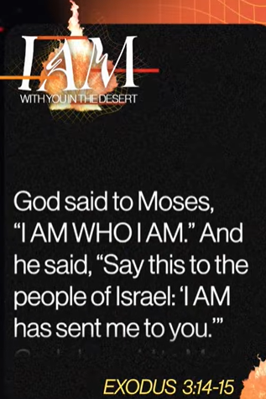 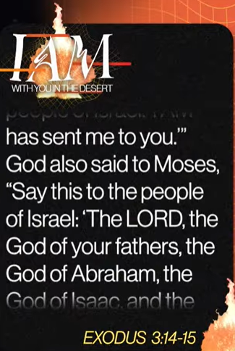

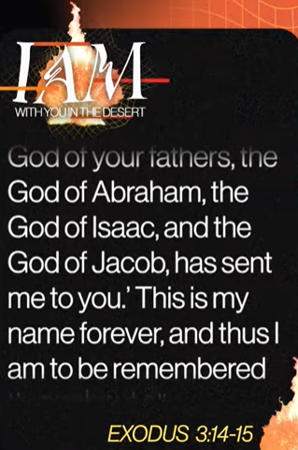 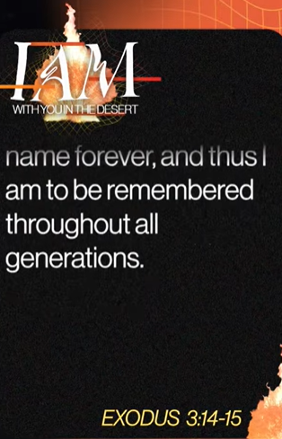

Exodus 3:14-15

English Standard Version

**14**God said to Moses, “I am who I am.”[[a](https://www.biblegateway.com/passage/?search=Exodus%203%3A14-15&version=ESV#fen-ESV-1594a)] And he said, “Say this to the people of Israel: ‘I am has sent me to you.’” **15**God also said to Moses, “Say this to the people of Israel: ‘The Lord,[[b](https://www.biblegateway.com/passage/?search=Exodus%203%3A14-15&version=ESV#fen-ESV-1595b)] the God of your fathers, the God of Abraham, the God of Isaac, and the God of Jacob, has sent me to you.’ This is my name forever, and thus I am to be remembered throughout all generations.

The main point of **Exodus 3:14-15** is God’s self-revelation to  [**Moses**](https://www.google.com/search?q=Moses&kgmid=/m/04yfh&sa=X&ved=2ahUKEwix69SlkfuSAxVsDjQIHX_7MbkQ3egRegQIAhAD) as the eternal, self-existent, and faithful **Covenant God** who is personally present to deliver His people.

The passage breaks down into these core revelations:

* **Divine Self-Existence**: By identifying as "**I AM WHO I AM**" (*Ehyeh Asher Ehyeh*), God declares His **aseity**—the fact that He is uncreated, independent of all things, and the source of all being.
* **Eternal Constancy**: The name signifies that God is **immutable** (unchanging) and eternal. He is the same God who spoke to the patriarchs and remains faithful to His promises across all generations.
* **Active Presence & Sufficiency**: The Hebrew verb for "I AM" (*hayah*) has an active quality, often translated as "**I will be what I will be**". This reassures [Moses](https://www.google.com/search?q=Moses&kgmid=/m/04yfh&sa=X&ved=2ahUKEwix69SlkfuSAxVsDjQIHX_7MbkQ3egRegQIBRAE) that God will be whatever is needed—a protector, provider, or deliverer—to fulfill the mission of freeing Israel.
* **Covenant Identity**: Verse 15 explicitly links the name "**I AM**" with "**The LORD**" (*Yahweh*), identifying Him as the God of [**Abraham**](https://www.google.com/search?q=Abraham&kgmid=/m/0pwb&sa=X&ved=2ahUKEwix69SlkfuSAxVsDjQIHX_7MbkQ3egRegQIBRAH)**,**[**Isaac**](https://www.google.com/search?q=Isaac&kgmid=/m/03xqw&sa=X&ved=2ahUKEwix69SlkfuSAxVsDjQIHX_7MbkQ3egRegQIBRAJ)**, and**[**Jacob**](https://www.google.com/search?q=Jacob&kgmid=/m/0jt0lm_&sa=X&ved=2ahUKEwix69SlkfuSAxVsDjQIHX_7MbkQ3egRegQIBRAL). This establishes that the impending Exodus is not just a random rescue but the fulfillment of an ancient, ongoing covenant.
* **A "Memorial" Forever**: God declares this as His "name forever" and His "memorial to all generations," commanding that He be remembered and worshiped by this specific identity throughout history.

If you're interested, I can provide more detail on the **Hebrew wordplay** in these verses or explain how this passage relates to the **"I Am" statements of Jesus** in the New Testament.

45:00/1:15:02



The Desert doesn’t disqualify you; it’s where God delivers your destination.

That is a powerful summary of the **biblical theology of the wilderness**. In Scripture, the "desert" is rarely a sign of God's rejection; instead, it is His primary **classroom for preparation**.

Here is how the desert functions as the place where God "delivers your destination":

* **Purification, Not Punishment**: The wilderness is a "crucible" designed to strip away reliance on worldly comforts and self-sufficiency. For the Israelites, the 40-year journey wasn't just a detour; it was a necessary period to transform a "slave mentality" into a "covenant identity".
* **A Place of Revelation**: In Hebrew, the word for desert is ***Midbar***, which shares a root with ***Dabar*** ("to speak"). It is the place where the "noise" of the world is silenced so God’s voice can be heard clearly, as seen when He spoke to **Moses** from the burning bush.
* **Training for the Mission**: Almost every major biblical leader was "processed" through a desert before their greatest work:
  + **Moses** spent 40 years as a humble shepherd in Midian before leading the Exodus.
  + **David** was formed for kingship while hiding in desert caves from Saul.
  + **Jesus** was led by the Spirit into the wilderness specifically to prepare for His public ministry.
* **The Bridge to the Promise**: The desert is the only road to the **Promised Land**. It is where you learn to trust God for daily "manna" (provision) so that when you reach your destination, you have the character to handle the abundance without losing your faith.

If you'd like, I can:

* Explore the **specific lessons** God taught Israel in their 40-year wandering
* Break down the **Hebrew wordplay** between "desert" and "speaking" in more detail
* Discuss how to **identify "desert seasons"** in your own life right now

02/28/2026, Menlo Church Worship, Legacy (last week)

https://www.youtube.com/live/EYP2zTQK3QE?si=L1iGmo0BEvQpljhN

“I Am With You in the Desert | I Am: The God Who Gets Close,” Phil EuBank, Lead Pastor

We are in the new series of “I Am: Arrival” Series. Today, we start with Exodus chapter 3.

Summary

1. God brings Isarael people to the desert. Desert is the most barren place to refine our faith.

2. Exodus 3:1-4: God call Moses to a divine mission.

3. Exodus 3:5: Mosses sees God.

4. Exodus 3:7-8: God commits to Isarael people for Promised Land.

5. Exodus 3:14-15: God lead Isarael people to the Promised Land.

Conclusion:

Isarael people lack of faith; God punishes them in desert for 40 years before bring them to promised land.